CURRENT AFFAIRS –JULY 2017

 | The Unique Identification Authority of India (UIDAI) has launched ‘mAadhaar’, a new mobile application for syncing Aadhaar data on mobile phones.
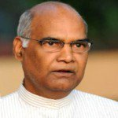 | Former governor Ram Nath Kovind was elected as India’s 14th President. He will be only the second Dalit leader after K R Narayanan since Independence to occupy India’s highest ceremonial post.
 | India will host Global Conference on Cyber Space (GCCS) 2017, the world’s largest conference on cyber space and related issues in New Delhi in November 2017
 | England’s women’s cricket team won 2017 ICC World Cup title by defeating India by 9 runs at Lord’s Cricket Ground in London. It was England’s fourth Women’s World Cup title. Besides the inaugural edition in 1973, England had won the World Cup in 1993 and 2009 as well.
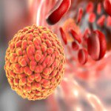 | Researchers San Antonio Catholic University of Murcia, Spain have discovered novobiocin compound that could be used as a potential drug to fight the effects of a Zika virus infection.

CURRENT AFFAIRS –JULY 2017

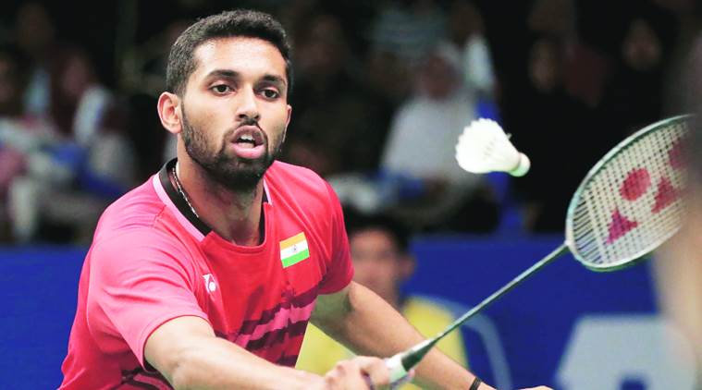 | Indian Shuttler H S Prannoy won the 2017 Yonex US Open Grand Prix Gold badminton tournament title. It was his third grand prix gold title of badminton.
 | Internationally-renowned space scientist and former chairman of ISRO (Indian Space Research Organization), Udupi Ramachandra Rao passed away in Bengaluru. He was 85.
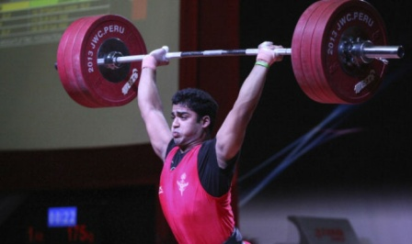 | India’s Ajay Singh has won bronze medal in the 2017 Asian Youth and Junior Weightlifting Championships held at Kathmandu, Nepal. He got third place in 77 kgs men’s junior category by lifting 143 kgs in snatch and 172 kgs in clean and jerk
 | The International Tiger Day (also known as Global Tiger Day) is celebrated every year on 29 July to raise awareness for tiger conservation. The goal of observance of the day is to promote the protection and expansion of the wild tiger’s habitats and to gain support through awareness for tiger conservation.
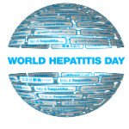 | The World Hepatitis Day is being observed every year on July 28 around the world by World Health Organization (WHO) to spread awareness about viral hepatitis. This year the theme of the Day is – “Eliminate Hepatitis”.

