CURRENT AFFAIRS –JULY 2017
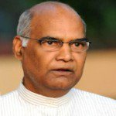 | Ram Nath Kovind was elected as India’s 14th President.
 | England’s women’s cricket team won 2017 ICC World Cup title by defeating India by 9 runs at Lord’s Cricket Ground in London.
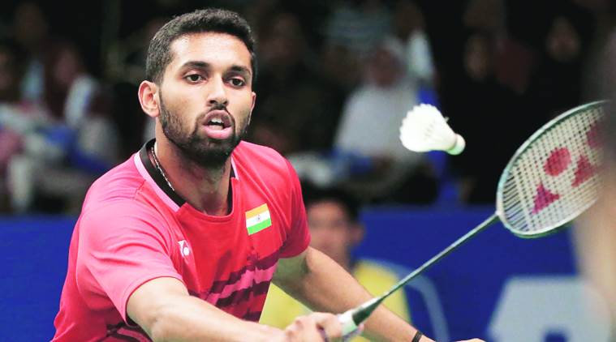 | Indian Shuttler H S Prannoy won the 2017 Yonex US Open Grand Prix Gold badminton tournament title.
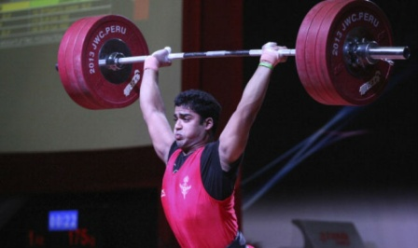 | India’s Ajay Singh has won bronze medal in the 2017 Asian Youth and Junior Weightlifting Championships held at Kathmandu, Nepal.
 | The International Tiger Day (also known as Global Tiger Day) is celebrated every year on 29 July to raise awareness for tiger conservation.
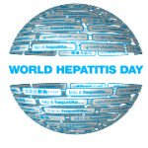 | The World Hepatitis Day is being observed every year on July 28 around the world by World Health Organization (WHO) to spread awareness about viral hepatitis. This year the theme of the Day is – “Eliminate Hepatitis”.

